MIDLAND BONSAI SOCIETY ANNUAL SHOW

WHEN | SUNDAY 12th JUNE, 2022, 10:30am till 16:00pm
WHERE | Birmingham Botanical Gardens, Westbourne Rd. Edgbaston, Birmingham, B15 3TR
Entrance to the show is free once entry has been gained to the Gardens and the following attractions will be offered for your entertainment:-
- An exhibition of trees by members who will be competing in various classes
- A display by Redditch Bonsai Society
- There will be talks at 12:00 and 14:00, subjects T.B.A.
- There will be demonstrations throughout the day
- There will be a Tombola with an eclectic range of prizes
- David Cheshire Bonsai will give you the opportunity to purchase trees and many bonsai sundries
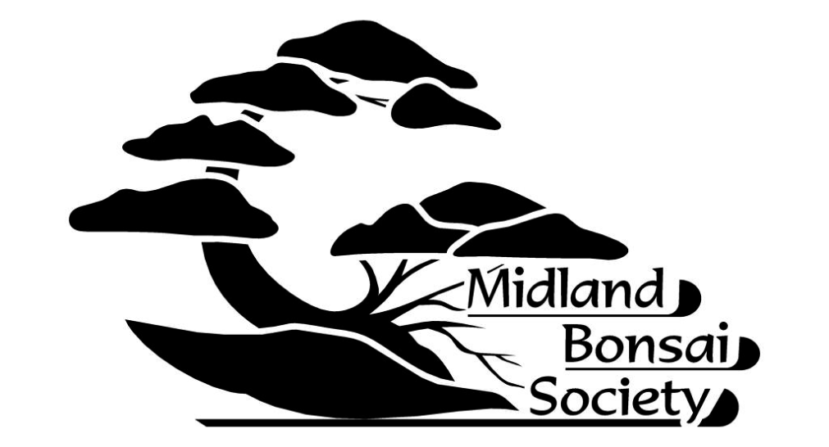
- Funky Fish Ceramics will be selling their range of unique pots
- Society members will be on hand to offer advice on any aspect of bonsai care
For more information:
Phone Richard Gilkes on 07803 593024
or visit www.midlandbonsai.org

