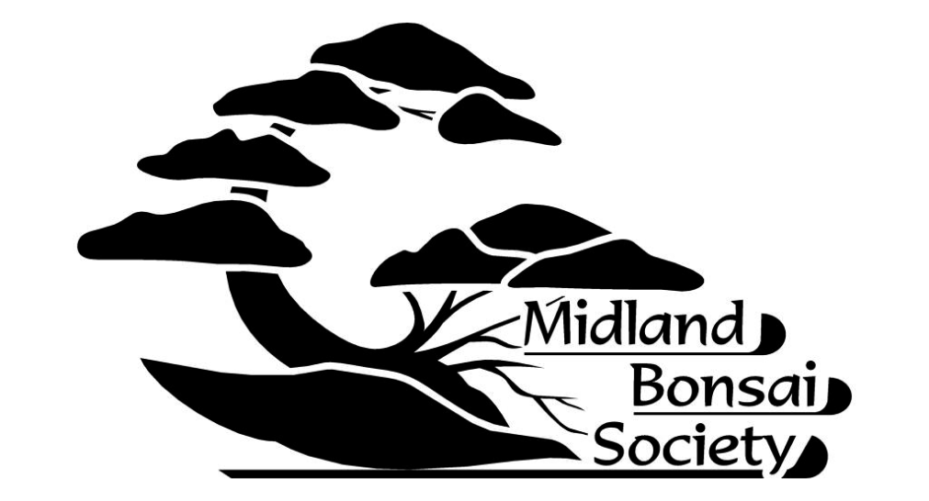

ANNUAL SHOW

WHEN | SUNDAY 9th JUNE 2024, 10:30AM – 16:00PM
WHERE | Birmingham Botanical Gardens, Westbourne Rd. Edgbaston, Birmingham, B15 3TR
Entrance to the show is FREE (once entry has been gained to the Gardens).
The following attractions will be offered for your enjoyment:
- An exhibition of Bonsai trees by Members competing in various Classes
- A display by Redditch Bonsai Society
- There will be talks at 12:00 and 14:00, subjects T.B.A.
- There will also be demonstrations throughout the day
- There will be a tombola with an eclectic range of prizes!
- David Cheshire Bonsai will give you the opportunity to purchase Bonsai Trees and MANY Bonsai Sundries
- Funky Fish Ceramics will be selling their exquisite range of unique HAND-MADE Bonsai Pots
- Society Members will be available to offer advice on ANY aspect of Bonsai Care
For more information:
Phone Secretary, Richard Gilkes on 07803 593024
or visit www.MidlandBonsai.org

